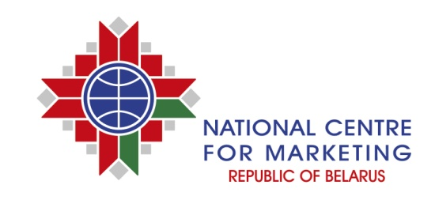
INFORMATION AND ADVERTISING SERVICES
The National Centre for Marketing of the Ministry of Foreign Affairs of the Republic of Belarus promotes the development of Belarusian business entities with a view to increase its efficiency. The National Centre for Marketing provides comprehensive information and advertising services through its print editions «Market conditions», «Export of Belarus» and through its online resources.

publication of advertising materials in the print editions
- «Export of Belarus» is an advertising and information catalogue. The purpose of this edition is to present the export potential of the Republic of Belarus and Belarusian companies on foreign markets. The catalogue is distributed in print and electronic version at major international events with participation of foreign missions of the Republic of Belarus and the foreign partners of the National Centre for Marketing in more than 150 countries all over the world.
- «Market conditions» is an information-analytical journal. The print edition is targeted at representatives of business circles of the Republic of Belarus. The journal publishes unique analytical information on foreign markets conditions, the opportunity to enter these markets, promising directions of economic and trade cooperation, especially cooperation with foreign counterparts. Also there is information about successfully implemented projects and upcoming business events. «Market conditions» is published in Russian.

design of commercial advertising printed products
Design of prospects, flyers, brochures, etc. is being developed under individual orders in accordance with modern requirements and best international practices.

PLACEMENT OF ADVERTISING BANNERS ON THE WEBSITE WWW.EXPORT.BY
Placement of information in print and online resources is a simple and reliable way to convey information about a company, its products and services to target audience anywhere in the world.

For issues of advertising in print media and design of commercial advertising printed products, please contact: 220004, Minsk, 7, Pobediteley Ave., Editing and Publishing Department.

For further information please visit our websites www.icetrade.by, www.ncmps.by, www.export.by, www.goszakupki.by.

